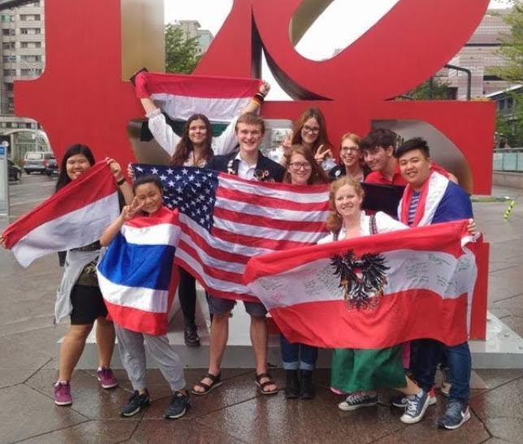
Rotary International High School Exchange Program

Rotary District 7910 participates in the Rotary Youth Exchange Program for high school students. Two programs are available, and students can apply to either program. All Rotary Youth Exchange programs are run by volunteer Rotarians and comply with all U.S. State Dept. regulations. Rotary clubs generously subsidize the program making these exchanges an affordable option.
Short Term (Family-to-Family) Program – Participating students are matched with a student and family in another country. The U.S. student travels to the host country and stays with the host family for 3-4 weeks, immersing themselves in the host country’s language and culture. Then the U.S. student and their host sibling travel back to the United States and the foreign student stays with their U.S. family for a similar length of time. This exchange generally occurs during the summer. Over 20 countries are available to choose from.
Long Term (Academic Year) Program – Long term exchange students live with host families while attending high school in one of 40 participating countries for a full academic year. Students become fluent in the local language, build lifelong friendships, and develop an in-depth understanding of the people, traditions, culture, food, and history of their host country -- a truly international education with benefits that last a lifetime.
What are you waiting for? A beautiful world awaits!

Want more information? Check out our website: Exchangestudent.org.
Ready to Apply? Contact us at: youthexchange7910@gmail.com
Deadlines: Long-term applications are due by December 1st for the following academic year. Short term applications are considered on a rolling basis from January 1st – May 1st. Contact us early for details.



